Interval Scale
# Source: AI Source: Provided by: [Data Path: Persons Table -> ID Column: 1, Name_En Column: Motasem Essam] -> From: [ChatGPT] on [7/17/2026]
The Interval Scale is the third level of measurement. It measures data using ordered values with equal intervals between consecutive values, but it does not have a true (absolute) zero point. Because the intervals are equal, differences between values are meaningful, but ratios are not.
An interval scale provides more quantitative information than the Nominal and Ordinal scales, allowing many mathematical and statistical operations.

Definition
# Source: AI Source: Provided by: [Data Path: Persons Table -> ID Column: 1, Name_En Column: Motasem Essam] -> From: [ChatGPT] on [7/17/2026]
An Interval Scale is a measurement scale in which values are ordered, the intervals between values are equal and meaningful, but the zero point is arbitrary rather than absolute.

Purpose
# Source: AI Source: Provided by: [Data Path: Persons Table -> ID Column: 1, Name_En Column: Motasem Essam] -> From: [ChatGPT] on [7/17/2026]
The interval scale is used to:
- Measure quantitative variables with equal spacing.
- Compare differences between values.
- Perform arithmetic operations involving addition and subtraction.
- Support statistical analysis.
- Represent measurements where zero does not indicate the complete absence of the quantity.

Characteristics
# Source: AI Source: Provided by: [Data Path: Persons Table -> ID Column: 1, Name_En Column: Motasem Essam] -> From: [ChatGPT] on [7/17/2026]
An interval scale:
- Classifies observations.
- Has a meaningful order.
- Has equal intervals between values.
- Has no true zero.
- Allows meaningful differences.
- Does not allow meaningful ratios.

Properties
# Source: AI Source: Provided by: [Data Path: Persons Table -> ID Column: 1, Name_En Column: Motasem Essam] -> From: [ChatGPT] on [7/17/2026]
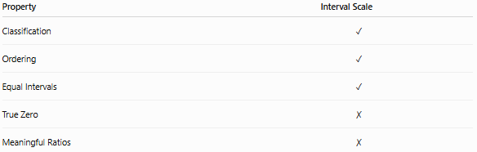
Property | Interval Scale
Classification | ✓
Ordering | ✓
Equal Intervals | ✓
True Zero | ✗
Meaningful Ratios | ✗

Why There Is No True Zero
# Source: AI Source: Provided by: [Data Path: Persons Table -> ID Column: 1, Name_En Column: Motasem Essam] -> From: [ChatGPT] on [7/17/2026]
On an interval scale, zero is simply another point on the scale and does not represent the complete absence of the measured quantity.
Example:
Temperature in Celsius:
- 0°C does not mean "no temperature."
- It is simply the freezing point of water under standard atmospheric pressure.
Because of this:
- 20°C is not twice as hot as 10°C.
- Ratios are meaningless.

Examples
# Source: AI Source: Provided by: [Data Path: Persons Table -> ID Column: 1, Name_En Column: Motasem Essam] -> From: [ChatGPT] on [7/17/2026]
Temperature (Celsius)
The most common example of an interval scale.
Temperatures:
- -10°C
- 0°C
- 20°C
- 40°C
The difference between:
40°C − 30°C = 10°C
is the same as:
20°C − 10°C = 10°C
However:
40°C is not twice 20°C.

Temperature (Fahrenheit)
Also an interval scale.
Example:
32°F
is not the absence of heat.

Calendar Years
Examples:
- 1990
- 2000
- 2010
- 2020
The difference between:
2020 − 2010 = 10 years
is meaningful.
However:
Year 2000 is not twice Year 1000.

IQ Scores
Examples:
- IQ 80
- IQ 100
- IQ 120
The differences are meaningful.
However:
IQ 120 is not 20% more intelligent than IQ 100.

Mathematical Operations
# Source: AI Source: Provided by: [Data Path: Persons Table -> ID Column: 1, Name_En Column: Motasem Essam] -> From: [ChatGPT] on [7/17/2026]
Allowed
- Addition
- Subtraction
- Mean
- Variance
- Standard deviation
- Correlation
Example:
30°C − 20°C = 10°C

Not Meaningful
- Ratios
- Multiplication comparisons
- Division comparisons
Incorrect:
40°C is twice 20°C.

Statistical Measures
Appropriate statistics include:
- Mean
- Median
- Mode
- Range
- Variance
- Standard deviation
- Correlation
- Percentiles

Applications
# Source: AI Source: Provided by: [Data Path: Persons Table -> ID Column: 1, Name_En Column: Motasem Essam] -> From: [ChatGPT] on [7/17/2026]
Interval scales are commonly used in:
- Physics
- Meteorology
- Psychology
- Education
- Social sciences
- Standardized testing
- Economics (certain indices)
- Scientific research

Advantages
# Source: AI Source: Provided by: [Data Path: Persons Table -> ID Column: 1, Name_En Column: Motasem Essam] -> From: [ChatGPT] on [7/17/2026]
The interval scale:
- Preserves ordering.
- Has equal spacing.
- Supports many mathematical operations.
- Allows meaningful comparisons of differences.
- Enables advanced statistical analysis.

Limitations
# Source: AI Source: Provided by: [Data Path: Persons Table -> ID Column: 1, Name_En Column: Motasem Essam] -> From: [ChatGPT] on [7/17/2026]
The interval scale:
- Lacks a true zero.
- Cannot express meaningful ratios.
- Does not support statements like "twice as much."
- Some physical interpretations require a ratio scale instead.

Common Mistakes
# Source: AI Source: Provided by: [Data Path: Persons Table -> ID Column: 1, Name_En Column: Motasem Essam] -> From: [ChatGPT] on [7/17/2026]
- Treating interval data as ratio data.
Incorrect:
40°C is twice as hot as 20°C.

- Assuming zero means absence.
Incorrect:
0°C means no heat.

- Using ratio comparisons.
Correct:
40°C is 20°C warmer than 20°C.

Interval Scale vs. Ordinal Scale
# Source: AI Source: Provided by: [Data Path: Persons Table -> ID Column: 1, Name_En Column: Motasem Essam] -> From: [ChatGPT] on [7/17/2026]
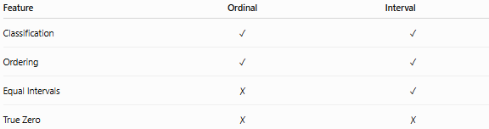
Feature | Ordinal | Interval
Classification | ✓ | ✓
Ordering | ✓ | ✓
Equal Intervals | ✗ | ✓
True Zero | ✗ | ✗
Example:
Ordinal:
- Poor
- Fair
- Good
- Excellent
Interval:
- Temperature in Celsius

Interval Scale vs. Ratio Scale
# Source: AI Source: Provided by: [Data Path: Persons Table -> ID Column: 1, Name_En Column: Motasem Essam] -> From: [ChatGPT] on [7/17/2026]
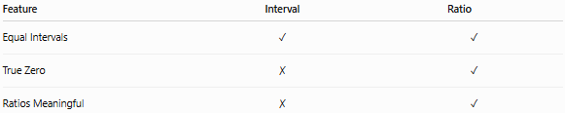
Feature | Interval | Ratio
Equal Intervals | ✓ | ✓
True Zero | ✗ | ✓
Ratios Meaningful | ✗ | ✓
Example:
Interval:
- Celsius temperature
Ratio:
- Kelvin temperature
- Length
- Mass
- Time duration

Comparison of Measurement Scales
# Source: AI Source: Provided by: [Data Path: Persons Table -> ID Column: 1, Name_En Column: Motasem Essam] -> From: [ChatGPT] on [7/17/2026]
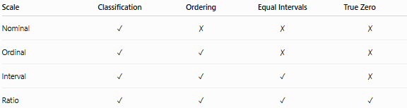
Scale | Classification | Ordering | Equal Intervals | True Zero
Nominal | ✓ | ✗ | ✗ | ✗
Ordinal | ✓ | ✓ | ✗ | ✗
Interval | ✓ | ✓ | ✓ | ✗
Ratio | ✓ | ✓ | ✓ | ✓

Key Points
# Source: AI Source: Provided by: [Data Path: Persons Table -> ID Column: 1, Name_En Column: Motasem Essam] -> From: [ChatGPT] on [7/17/2026]
- The Interval Scale has:
  - Classification
  - Ordering
  - Equal intervals
- It does not have a true zero.
- Differences between values are meaningful.
- Ratios between values are not meaningful.
- Common examples:
  - Celsius temperature
  - Fahrenheit temperature
  - Calendar years
  - IQ scores

Conclusion
# Source: AI Source: Provided by: [Data Path: Persons Table -> ID Column: 1, Name_En Column: Motasem Essam] -> From: [ChatGPT] on [7/17/2026]
The Interval Scale is a quantitative measurement scale that provides ordered values with equal and meaningful intervals, allowing accurate comparison of differences between observations. However, because it lacks a true zero, ratio comparisons are invalid. It is widely used for measurements such as Celsius and Fahrenheit temperatures, calendar years, and IQ scores, making it an essential scale in science, education, psychology, and statistical analysis where equal spacing is important but an absolute zero does not exist.

